Chapter 8, Solution 58.

In the circuit of Fig. 8.104, the switch has been in position 1 for a long time but moved to position 2 at t = 0. Find:

- v(0⁺), dv(0⁺)/dt
- v(t) for t ≥ 0.

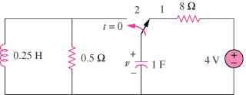

Figure 8.104
For Prob. 8.58.

Solution

- Let i =inductor current, v = capacitor voltage i(0) =0, v(0) = 4

- For , the circuit is a source-free RLC parallel circuit.

Thus,

v(0) = 4 = A₁

V

